# This is a very first cut of the fungal interceptions data. It's pretty clean, but there are likely still issues with synonomy. Some have been detected and fixed already but I haven't systematically gone through to see how thorough that is. There is a lot more that could be done (even with these data) but including and comparing with data from the 1980- would add a lot for sure.

Edited: JGarnas_2024.01.13

# By kingdom and decade of interception

## So, WAY more arthropods. only 231 total fungal detections. Consider whether this is enough to do anything with. Perhaps the story is that visual inspection is sorely inadequate.

|  |
| --- |

|  |  | Actinobacteriota | Annelida | Arthropoda | Ascomycota | Basidiomycota | Chordata | Foraminifera | Mollusca | Nematoda | Oomycota | Proteobacteria | Tracheophyta |
| --- | --- | --- | --- | --- | --- | --- | --- | --- | --- | --- | --- | --- | --- |
|  | 278 | 0 | 0 | 0 | 0 | 0 | 0 | 0 | 0 | 0 | 0 | 0 | 0 |
| Animalia | 7 | 0 | 4 | 2822 | 0 | 0 | 1 | 0 | 55 | 14 | 0 | 0 | 0 |
| Bacteria | 5 | 1 | 0 | 0 | 0 | 0 | 0 | 0 | 0 | 0 | 0 | 1 | 0 |
| Chromista | 0 | 0 | 0 | 0 | 0 | 0 | 0 | 1 | 0 | 0 | 2 | 0 | 0 |
| Fungi | 0 | 0 | 0 | 0 | 221 | 10 | 0 | 0 | 0 | 0 | 0 | 0 | 0 |
| Plantae | 0 | 0 | 0 | 0 | 0 | 0 | 0 | 0 | 0 | 0 | 0 | 0 | 5 |

# By kingdom and phylum

|  |  | Animalia | Bacteria | Chromista | Fungi | Plantae |
| --- | --- | --- | --- | --- | --- | --- |
|  | 278 | 7 | 5 | 0 | 0 | 0 |
| Actinobacteriota | 0 | 0 | 1 | 0 | 0 | 0 |
| Annelida | 0 | 4 | 0 | 0 | 0 | 0 |
| Arthropoda | 0 | 2822 | 0 | 0 | 0 | 0 |
| Ascomycota | 0 | 0 | 0 | 0 | 221 | 0 |
| Basidiomycota | 0 | 0 | 0 | 0 | 10 | 0 |
| Chordata | 0 | 1 | 0 | 0 | 0 | 0 |
| Foraminifera | 0 | 0 | 0 | 1 | 0 | 0 |
| Mollusca | 0 | 55 | 0 | 0 | 0 | 0 |
| Nematoda | 0 | 14 | 0 | 0 | 0 | 0 |
| Oomycota | 0 | 0 | 0 | 2 | 0 | 0 |
| Proteobacteria | 0 | 0 | 1 | 0 | 0 | 0 |
| Tracheophyta | 0 | 0 | 0 | 0 | 0 | 5 |

# By kingdom and decade of interception

### What's up with the missing decades for fungi? Great Depression/WWII impacts on inspection, or just vagaries of reporting?

| Kingdom/Decade | 1910 | 1920 | 1930 | 1940 | 1950 | 1960 | 1970 | 1980 |
| --- | --- | --- | --- | --- | --- | --- | --- | --- |
| z_Not listed | 1 | 2 | 3 | 8 | 10 | 4 | 12 | 7 |
| Animalia | 306 | 3439 | 2237 | 2392 | 3376 | 4894 | 6658 | 11885 |
| Bacteria | 35 | 243 | 4 | 0 | 0 | 0 | 0 | 0 |
| Chromista | 0 | 0 | 0 | 0 | 3 | 2 | 0 | 0 |
| Fungi | 18 | 157 | 1 | 0 | 209 | 220 | 261 | 20 |
| Plantae | 0 | 5 | 0 | 0 | 1 | 0 | 0 | 6 |

# **FUNGI only from here**

* nearly all ascomycota (where most plant pathogens sit).
* At first look there are some pathogen groups listed, though I still have to look at species.
* Even at the genus level, detections are low and sporadic.

|  | 1910 | 1920 | 1940 | 1950 | 1960 | 1970 |
| --- | --- | --- | --- | --- | --- | --- |
| Ascomycota, , Achorella | 0 | 0 | 0 | 1 | 0 | 0 |
| Ascomycota, , Acremoniella | 1 | 0 | 0 | 0 | 0 | 0 |
| Ascomycota, , Ascochyta | 0 | 0 | 0 | 1 | 0 | 0 |
| Ascomycota, , Bactridium | 0 | 1 | 0 | 0 | 0 | 0 |
| Ascomycota, , Botryodiplodia | 0 | 1 | 0 | 0 | 0 | 0 |
| Ascomycota, , Camarosporium | 0 | 0 | 0 | 1 | 3 | 1 |
| Ascomycota, , Cephalosporium | 1 | 2 | 0 | 0 | 0 | 0 |
| Ascomycota, , Cephalothecium | 2 | 2 | 0 | 0 | 0 | 0 |
| Ascomycota, , Chaetodiplodia | 3 | 0 | 0 | 0 | 0 | 0 |
| Ascomycota, Apiosporaceae, Apiospora | 0 | 0 | 0 | 2 | 1 | 0 |
| Ascomycota, Apiosporaceae, Arthrinium | 0 | 0 | 0 | 1 | 0 | 1 |
| Ascomycota, Aspergillaceae, Aspergillus | 28 | 11 | 0 | 1 | 0 | 0 |
| Ascomycota, Asterinaceae, Asterina | 0 | 0 | 0 | 1 | 0 | 0 |
| Ascomycota, Botryosphaeriaceae, Botryosphaeria | 0 | 0 | 0 | 1 | 2 | 0 |
| Ascomycota, Botryosphaeriaceae, Microdiplodia | 0 | 0 | 0 | 0 | 1 | 0 |
| Ascomycota, Botryosphaeriaceae, Neofusicoccum | 0 | 0 | 1 | 4 | 0 | 0 |
| Ascomycota, Calcarisporiaceae, Calcarisporium | 0 | 0 | 0 | 0 | 1 | 0 |
| Ascomycota, Ceratocystidaceae, Ceratocystis | 0 | 0 | 0 | 0 | 2 | 0 |
| Ascomycota, Ceratocystidaceae, Chalaropsis | 0 | 0 | 0 | 1 | 0 | 0 |
| Ascomycota, Ceratocystidaceae, Endoconidiophora | 0 | 0 | 0 | 0 | 1 | 0 |
| Ascomycota, Ceratocystidaceae, Thielaviopsis | 0 | 0 | 0 | 0 | 1 | 0 |
| Ascomycota, Chaetomiaceae, Chaetomium | 5 | 1 | 1 | 0 | 0 | 0 |
| Ascomycota, Chaetosphaeriaceae, Pseudolachnella | 0 | 0 | 0 | 0 | 1 | 0 |
| Ascomycota, Clavicipitaceae, Aschersonia | 0 | 0 | 0 | 1 | 0 | 0 |
| Ascomycota, Clavicipitaceae, Hypocrella | 0 | 0 | 0 | 1 | 0 | 0 |
| Ascomycota, Coryneliaceae, Caliciopsis | 0 | 0 | 0 | 0 | 0 | 2 |
| Ascomycota, Diaporthaceae, Phomopsis | 0 | 0 | 0 | 0 | 6 | 0 |
| Ascomycota, Didymellaceae, Ascochyta | 2 | 0 | 2 | 7 | 39 | 21 |
| Ascomycota, Didymellaceae, Boeremia | 0 | 0 | 0 | 0 | 1 | 0 |
| Ascomycota, Didymellaceae, Cerebella | 0 | 1 | 0 | 0 | 0 | 0 |
| Ascomycota, Didymellaceae, Didymella | 0 | 0 | 3 | 16 | 4 | 0 |
| Ascomycota, Didymellaceae, Epicoccum | 0 | 0 | 0 | 12 | 0 | 0 |
| Ascomycota, Didymellaceae, Stagonosporopsis | 0 | 0 | 0 | 1 | 0 | 0 |
| Ascomycota, Hypocreaceae, Acrostalagmus | 2 | 4 | 0 | 0 | 0 | 0 |
| Ascomycota, Melanconidaceae, Prosthecium | 0 | 0 | 0 | 1 | 0 | 0 |
| Ascomycota, Melanommataceae, Camposporium | 0 | 0 | 0 | 0 | 1 | 0 |
| Ascomycota, Meliolaceae, Amazonia | 0 | 0 | 0 | 0 | 0 | 1 |
| Ascomycota, Micropeltidaceae, Chaetothyrina | 0 | 0 | 0 | 0 | 15 | 31 |
| Ascomycota, Microthyriaceae, Asterinella | 0 | 0 | 0 | 1 | 0 | 0 |
| Ascomycota, Microthyriaceae, Maublancia | 0 | 0 | 0 | 1 | 0 | 0 |
| Ascomycota, Mycosphaerellaceae, Asperisporium | 0 | 0 | 0 | 5 | 0 | 0 |
| Ascomycota, Mycosphaerellaceae, Cercospora | 1 | 0 | 3 | 20 | 55 | 42 |
| Ascomycota, Mycosphaerellaceae, Cercosporella | 0 | 0 | 0 | 1 | 2 | 0 |
| Ascomycota, Mycosphaerellaceae, Chuppomyces | 0 | 0 | 3 | 7 | 0 | 0 |
| Ascomycota, Mycosphaerellaceae, Clarohilum | 0 | 0 | 0 | 1 | 0 | 0 |
| Ascomycota, Mycosphaerellaceae, Mycosphaerella | 0 | 0 | 17 | 48 | 0 | 1 |
| Ascomycota, Mycosphaerellaceae, Nothopassalora | 0 | 0 | 0 | 1 | 0 | 0 |
| Ascomycota, Mycosphaerellaceae, Passalora | 5 | 0 | 0 | 5 | 10 | 0 |
| Ascomycota, Mycosphaerellaceae, Pluripassalora | 0 | 0 | 0 | 0 | 4 | 0 |
| Ascomycota, Mycosphaerellaceae, Pseudocercospora | 0 | 0 | 3 | 43 | 55 | 14 |
| Ascomycota, Mycosphaerellaceae, Rosisphaerella | 0 | 0 | 0 | 2 | 0 | 0 |
| Ascomycota, Mycosphaerellaceae, Scolecostigmina | 0 | 0 | 0 | 2 | 4 | 0 |
| Ascomycota, Mycosphaerellaceae, Sphaerulina | 0 | 0 | 1 | 2 | 0 | 0 |
| Ascomycota, Myrotheciomycetaceae, Trichothecium | 2 | 7 | 0 | 0 | 0 | 0 |
| Ascomycota, Nectriaceae, Allantonectria | 0 | 0 | 0 | 1 | 0 | 0 |
| Ascomycota, Ophiostomataceae, Ophiostoma | 0 | 0 | 0 | 0 | 1 | 1 |
| Ascomycota, Ophiostomataceae, Sporothrix | 0 | 0 | 0 | 3 | 0 | 0 |
| Ascomycota, Orbiliaceae, Arthrobotrys | 0 | 0 | 0 | 1 | 0 | 0 |
| Ascomycota, Phacidiaceae, Allantophomopsis | 0 | 0 | 0 | 1 | 0 | 0 |
| Ascomycota, Phaeochoraceae, Phaeochoropsis | 0 | 0 | 0 | 2 | 1 | 0 |
| Ascomycota, Phyllachoraceae, Coccodiella | 0 | 0 | 0 | 0 | 2 | 0 |
| Ascomycota, Phyllachoraceae, Coccostromopsis | 0 | 0 | 0 | 1 | 0 | 0 |
| Ascomycota, Pleosporaceae, Alternaria | 12 | 1 | 2 | 28 | 8 | 0 |
| Ascomycota, Sclerotiniaceae, Botryotinia | 13 | 0 | 0 | 15 | 1 | 0 |
| Ascomycota, Sclerotiniaceae, Botrytis | 41 | 24 | 9 | 21 | 0 | 0 |
| Ascomycota, Seuratiaceae, Seuratia | 0 | 0 | 0 | 1 | 0 | 0 |
| Ascomycota, Trichosphaeriaceae, Nigrospora | 1 | 1 | 0 | 0 | 0 | 0 |
| Ascomycota, Venturiaceae, Coleroa | 0 | 0 | 0 | 0 | 5 | 0 |
| Ascomycota, Xylariaceae, Anthostomella | 0 | 0 | 0 | 2 | 1 | 0 |
| Basidiomycota, , Aecidium | 0 | 0 | 0 | 0 | 2 | 1 |
| Basidiomycota, Chaconiaceae, Chaconia | 0 | 0 | 0 | 0 | 1 | 2 |
| Basidiomycota, Phakopsoraceae, Bubakia | 0 | 0 | 0 | 0 | 13 | 12 |
| Basidiomycota, Phakopsoraceae, Cerotelium | 0 | 1 | 0 | 1 | 8 | 13 |
| Basidiomycota, Phakopsoraceae, Phakopsora | 0 | 0 | 0 | 1 | 0 | 0 |
|  |  |  |  |  |  |  |
|  |  |  |  |  |  |  |

# total_interceptions_fungi

**Caption:**

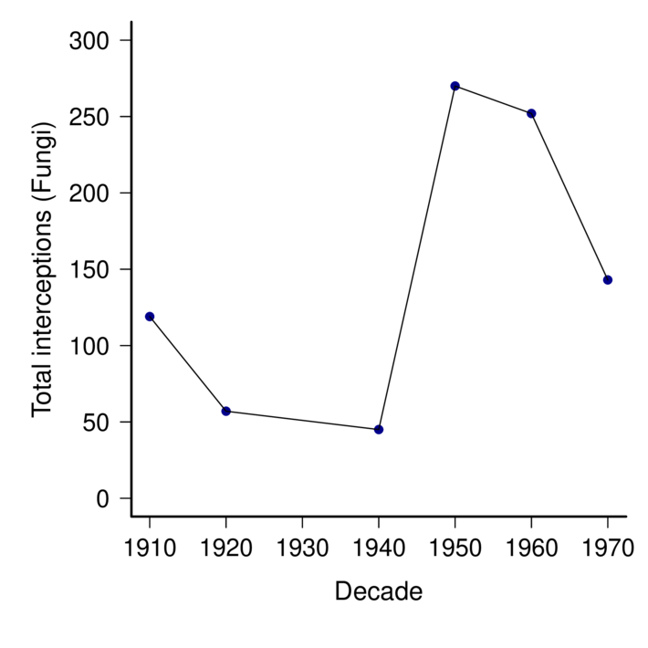

###### 01_total_interceptions_fungi.pdf

### Script file:

./interceptions_amyric/01_dataImport.r  
 Timestamp: Fri Dec 22 09:27:15 2023

## Notes:

# 02_mean_annual_interceptions_fungi.pdf.annot.md.annot.md

# mean_annual_interceptions_fungi

**Caption:**

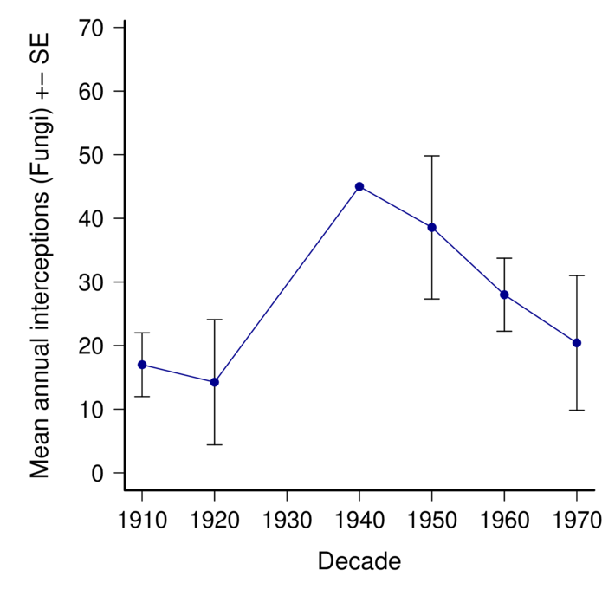

###### 02_mean_annual_interceptions_fungi.pdf

### Script file:

./interceptions_amyric/01_dataImport.r  
 Timestamp: Fri Dec 22 09:53:01 2023

## Notes:

# histogram_by_year

**Caption:**

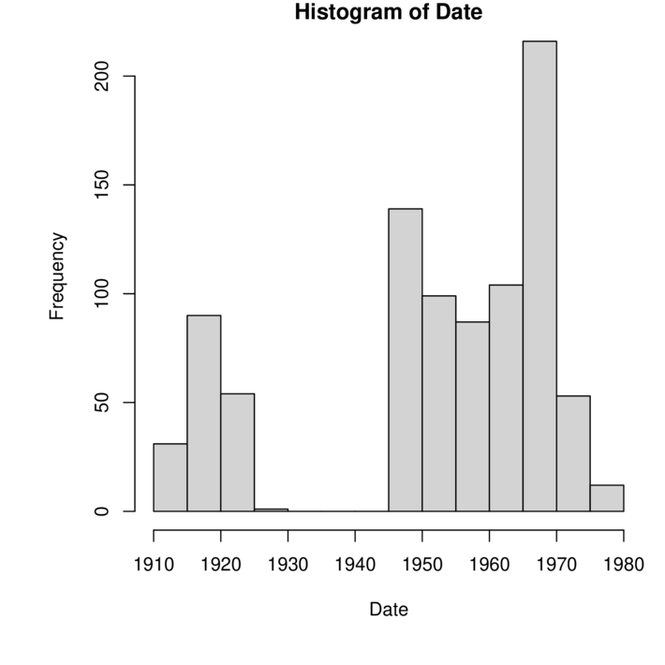

###### 03_histogram_by_year.pdf

## Just a few more graphs/tables -- this is all preliminary

# Cumulative detections, all fungi

**Caption:**

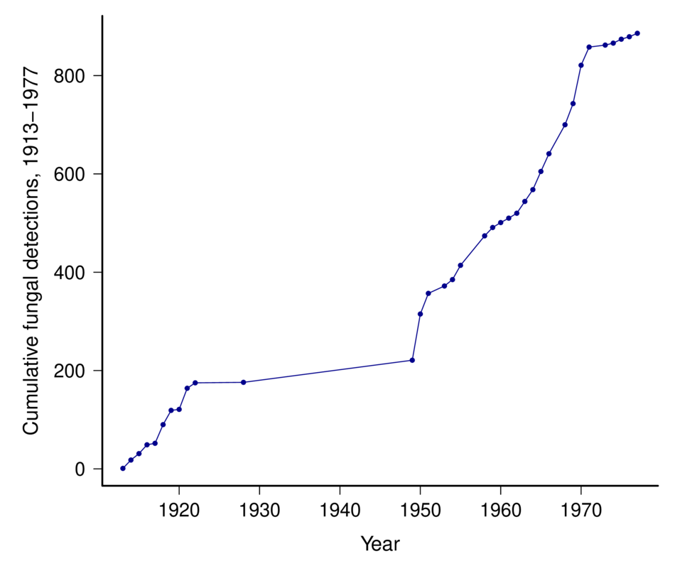

###### 04_cumulativedetections_fungi.pdf

# Detections by decade and country:

## Sorted by ALLDECADES

| Origin | 1910 | 1920 | 1940 | 1950 | 1960 | 1970 | alldecades |
| --- | --- | --- | --- | --- | --- | --- | --- |
| Mexico | 1 | 2 | 7 | 79 | 41 | 15 | 145 |
| Netherlands | 30 | 15 | 2 | 19 | 1 | 0 | 67 |
| Japan | 3 | 2 | 6 | 29 | 18 | 8 | 66 |
| Colombia | 5 | 1 | 1 | 6 | 24 | 13 | 50 |
| Ecuador | 7 | 1 | 1 | 4 | 9 | 6 | 28 |
| Guatemala | 4 | 1 | 1 | 5 | 10 | 6 | 27 |
| Panama | 0 | 1 | 2 | 8 | 13 | 2 | 26 |
| Dominican Republic | 0 | 0 | 1 | 2 | 12 | 10 | 25 |
| Brazil | 7 | 0 | 2 | 5 | 4 | 5 | 23 |
| France | 6 | 7 | 1 | 4 | 4 | 0 | 22 |
| Puerto Rico | 4 | 0 | 1 | 8 | 7 | 2 | 22 |
| UK | 8 | 5 | 0 | 4 | 4 | 0 | 21 |
| Italy | 0 | 1 | 2 | 10 | 7 | 0 | 20 |
| Unknown | 0 | 0 | 0 | 2 | 7 | 9 | 18 |
| Peru | 1 | 0 | 1 | 3 | 4 | 8 | 17 |
| Australia | 1 | 0 | 1 | 8 | 5 | 1 | 16 |
| Jamaica | 0 | 0 | 0 | 1 | 10 | 5 | 16 |
| South Africa | 0 | 5 | 0 | 6 | 5 | 0 | 16 |
| China | 7 | 1 | 2 | 3 | 0 | 0 | 13 |
| Costa Rica | 0 | 0 | 1 | 6 | 4 | 2 | 13 |
| El Salvador | 0 | 0 | 0 | 3 | 4 | 6 | 13 |
| Belgium | 4 | 1 | 2 | 4 | 0 | 0 | 11 |
| Venezuela | 1 | 0 | 0 | 3 | 3 | 4 | 11 |
| Argentina | 6 | 0 | 1 | 2 | 1 | 0 | 10 |
| Honduras | 0 | 0 | 1 | 4 | 3 | 2 | 10 |
| Haiti | 0 | 0 | 1 | 1 | 5 | 2 | 9 |
| Trinidad & Tobago | 1 | 0 | 0 | 2 | 2 | 3 | 8 |
| Bolivia | 0 | 0 | 0 | 0 | 4 | 3 | 7 |
| Cuba | 2 | 1 | 1 | 3 | 0 | 0 | 7 |
| Germany | 1 | 0 | 0 | 3 | 2 | 0 | 6 |
| New Zealand | 2 | 0 | 0 | 2 | 0 | 2 | 6 |
| Philippines | 2 | 1 | 0 | 0 | 2 | 1 | 6 |
| Spain | 2 | 0 | 0 | 1 | 2 | 1 | 6 |
| Bermuda | 0 | 0 | 1 | 4 | 0 | 0 | 5 |
| Hong Kong | 0 | 0 | 0 | 0 | 2 | 3 | 5 |
| India | 1 | 1 | 1 | 1 | 1 | 0 | 5 |
| Indonesia | 2 | 0 | 0 | 0 | 3 | 0 | 5 |
| Nicaragua | 0 | 0 | 0 | 0 | 1 | 4 | 5 |
| Africa | 0 | 3 | 0 | 0 | 0 | 1 | 4 |
| Barbados | 0 | 0 | 0 | 0 | 2 | 2 | 4 |
| Canada | 1 | 0 | 0 | 1 | 2 | 0 | 4 |
| Chile | 0 | 2 | 0 | 0 | 2 | 0 | 4 |
| Martinique | 0 | 0 | 1 | 1 | 1 | 1 | 4 |
| Portugal | 0 | 0 | 0 | 2 | 0 | 2 | 4 |
| Austria | 0 | 0 | 0 | 2 | 0 | 1 | 3 |
| Bahamas | 0 | 0 | 0 | 0 | 3 | 0 | 3 |
| Cape Verde | 1 | 2 | 0 | 0 | 0 | 0 | 3 |
| Greece | 0 | 0 | 0 | 1 | 1 | 1 | 3 |
| Grenada | 0 | 0 | 1 | 1 | 0 | 1 | 3 |
| Lebanon | 0 | 0 | 0 | 1 | 0 | 2 | 3 |
| St. Kitts & Nevis | 0 | 0 | 0 | 0 | 1 | 2 | 3 |
| St. Lucia | 0 | 0 | 0 | 0 | 1 | 2 | 3 |
| Taiwan | 0 | 0 | 0 | 0 | 3 | 0 | 3 |
| Angola | 0 | 0 | 0 | 2 | 0 | 0 | 2 |
| Antigua & Barbuda | 0 | 0 | 0 | 1 | 0 | 1 | 2 |
| Azores | 0 | 0 | 1 | 1 | 0 | 0 | 2 |
| Denmark | 0 | 0 | 0 | 1 | 1 | 0 | 2 |
| French Polynesia | 2 | 0 | 0 | 0 | 0 | 0 | 2 |
| Hawaii | 0 | 1 | 0 | 0 | 1 | 0 | 2 |
| Kenya | 0 | 0 | 0 | 2 | 0 | 0 | 2 |
| Nigeria | 0 | 0 | 0 | 2 | 0 | 0 | 2 |
| Papua New Guinea | 0 | 0 | 0 | 0 | 2 | 0 | 2 |
| Russia | 0 | 0 | 0 | 1 | 1 | 0 | 2 |
| Sint Maarten | 0 | 0 | 0 | 0 | 1 | 1 | 2 |
| Slovenia | 0 | 0 | 0 | 2 | 0 | 0 | 2 |
| Turkey | 0 | 0 | 1 | 1 | 0 | 0 | 2 |
| U.S. Virgin Islands | 2 | 0 | 0 | 0 | 0 | 0 | 2 |
| Vietnam | 0 | 0 | 0 | 0 | 2 | 0 | 2 |
| American Samoa | 1 | 0 | 0 | 0 | 0 | 0 | 1 |
| Cayman Islands | 0 | 0 | 0 | 1 | 0 | 0 | 1 |
| Central America | 0 | 1 | 0 | 0 | 0 | 0 | 1 |
| Europe | 0 | 0 | 0 | 0 | 1 | 0 | 1 |
| Fiji | 0 | 0 | 1 | 0 | 0 | 0 | 1 |
| Guadeloupe | 0 | 0 | 0 | 0 | 0 | 1 | 1 |
| Guyana | 1 | 0 | 0 | 0 | 0 | 0 | 1 |
| Hungary | 1 | 0 | 0 | 0 | 0 | 0 | 1 |
| Ireland | 0 | 1 | 0 | 0 | 0 | 0 | 1 |
| Israel | 0 | 0 | 0 | 0 | 1 | 0 | 1 |
| Laos | 0 | 1 | 0 | 0 | 0 | 0 | 1 |
| Liberia | 0 | 0 | 0 | 0 | 0 | 1 | 1 |
| Madeira | 1 | 0 | 0 | 0 | 0 | 0 | 1 |
| Serbia | 0 | 0 | 0 | 1 | 0 | 0 | 1 |
| Singapore | 1 | 0 | 0 | 0 | 0 | 0 | 1 |
| South Korea | 0 | 0 | 0 | 0 | 1 | 0 | 1 |
| St. Vincent & Grenadines | 0 | 0 | 0 | 0 | 0 | 1 | 1 |
| Thailand | 0 | 0 | 0 | 0 | 1 | 0 | 1 |
| Uruguay | 0 | 0 | 0 | 1 | 0 | 0 | 1 |